#tugassegitiga

def function(a, b, c):

if (a <= 0 ) and (b <= 0 ) and (c <= 0):

print("tudak ada segitiga yang dapat di bangun")

elif ((((a > b ) and (a > c)) and (a == b+c))

or (((b > a ) and (b > c)) and (b == a+c))

or (((c > b ) and (c > a)) and (c == b+a))):

print("tidak ada segitiga yang dapat di bangun")

elif (((a == b) and (b == c)) and (a == c)):

print("SEGITIGA SAMA SISI")

elif (((a == b) and (a != c)) or ((c == b) and (c != a)) or ((a == c) and (a!= b))):

print("segitiga SAMA KAKI")

elif ((a\*\*2 == b\*\*2 + c\*\*2) or (b\*\*2 == a\*\*2 + c\*\*2) or (c\*\*2 == b\*\*2 + a\*\*2)):

print("SEGITIGA SIKU SIKU")

elif ((((a > b ) and (a > c)) and (a < b+c))

or (((b > a ) and (b > c)) and (b < a+c))

or (((c > b ) and (c > a)) and (c < b+a))):

print("SEGITIGA BEBAS")

a = float(input("masukan sisi1 = "))

b = float(input("masukan sisi2 = "))

c = float(input("masukan sisi3 = "))

x,y,z = round(a),round(b),round(c)

function(x,y,z)

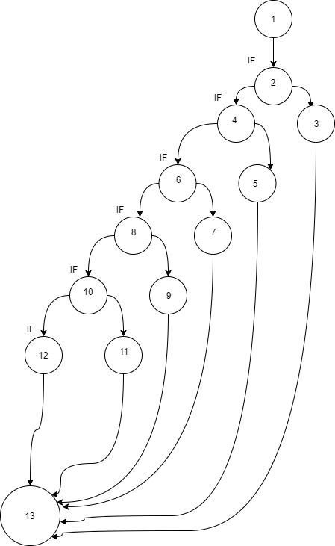

V(G)      = 17 edges – 13 nodes + 2

= 6

Hasil independent path pada contoh di atas dapat dijabarkan sebagai berikut:

Path 1 : 1-2-3-13

Path 2 : 1-2-4-5-13

Path 3 : 1-2-4-6-7-13

Path 4 : 1-2-4-6-8-9-13

Path 5 : 1-2-4-6-8-10-11-13

Path 6 : 1-2-4-6-8-10-12-13

Kasus uji harus diturunkan sehingga semua jalur ini dieksekusi